LZU1431263

Cloud Native Operations: Kubernetes and Helm
Table of Contents
LZU1431263 1
Cloud Native Operations: Kubernetes and Helm 1
1 Workshop Introduction 2
1.1 Objectives 3
1.2 Workshop cadence 3
1.3 Technical audience and pre-requisites 3
1.4 Material needed. 3
2 Pluralsight License 4
2.1 License Ordering 4
2.2 License Validation 4
3 Windows Platform Preparation 5
3.1 Third Party software installation 5
3.2 Disk space clean-up and availability 6
4 Section A: Nocentino Lab Installation 7
4.1 Download Nocentino lab OVA 7
4.2 Install Nocentino lab OVA 7
4.3 Test your SSH client sessions. 7
4.4 Understand Lab Environment 8
4.5 Personalize Lab Environment 9
4.6 Send “Nocentino Lab Ready” Screenshot 9
4.7 Understand the curriculum flow with Pluralsight 9
4.8 Understand On-premises vs. Off-premises vs. Hyperscaler 10
5 Section B: Kubernetes Installation and Configuration Fundamentals 10
5.1 Watch the video modules and download exercises 11
6 Section C: Manage the Kubernetes API Server and Pods 11
6.1 Watch the video modules and download exercises 12
7 Section D: Manage Kubernetes Controllers and Deployments 12
7.1 Watch the video modules and download exercises 12
8 Section E: Manage Kubernetes Storage and Scheduling 13
8.1 Watch the video modules and download exercises 13
9 Section F: Manage Kubernetes Networking, Services, and Ingress 13
9.1 Watch the video modules and download exercises 13
9.2 Wrap up of your Nocentino lab 14
10 Section G: HELM Lab Installation 14
10.1 Download HELM lab OVA 14
10.2 Install HELM lab OVA 14
11 Section G (cont.): Package Applications with Helm for Kubernetes 15
11.1 Watch the video modules and perform the exercises 16
12 Section H: HELM continuation and wrap up 16
12.1 HELM Wrap up instructions 16
13 Section I: Group Exercise #1 17
13.1 Lab preparation 17
13.2 Warm-up #1 17
13.3 Group Exercises questions #1 17
14 Section J: Group Exercise #2 17
14.1 PCC Lab preparation 17
14.2 Warm-up #2 18
14.3 Group Exercises questions #2 18
15 Section K: Final assessment test 18
15.1 Lab preparation for Final test 18
15.2 Final test 18

Workshop Introduction

Objectives
This workshop provides a high-level of understanding on how to create and use the main resources in a Kubernetes (k8s) cluster. Secondly, you will learn how to install and operate HELM version 3, gain skills on how to create, modify, and troubleshoot HELM charts and apply that understanding into your respective work as needed. You will be part of group exercises that will foster collaboration within the Cloud Native community in Ericsson, witness diverse ways to approach a problem and apply your skills in a test-environment. Participants can upgrade the learnt knowledge to Hyper Scaler and Container Image management via supplemental training.

Workshop cadence
It is a self-paced yet structured workshop where you are needed to dedicate the time and effort to work as a team in a 5-week period. On a weekly basis, you will watch videos, practice your skills via exercises, and meet with your instructors to allow you to ask technical questions.
Towards the end of the curriculum, group exercises will help you to develop team building while working on real-life projects needing knowledge of Kubernetes and HELM.
Weekly cohorts with experts are held to assess understanding of topics learnt, answering technical queries, checking progress of individuals, and setting ambition for next week. Email/MS Team Channels will be used for communications.

Technical audience and pre-requisites
This workshop is suitable for anyone who wants to learn the basic knowledge on Kubernetes, the basic knowledge of HELM packaging with chart manipulations, and apply it all in a delivery role or entry level DevOps role. Intermediate Linux knowledge from each participant is highly recommended to keep up with the cadence.

Material needed.
Windows Laptop
32 gig memory preferred (16 gig minimum), 50Gig free space and few 3rd party software.
Pluralsight learner license
NOTE: No other platforms supported

Pluralsight License
Estimated hours: 0.5

License Ordering
If you don’t already have an active license from Pluralsight, click on the below link and follow the instructions to request a new one:
- https://ericsson.sharepoint.com/sites/learningatericsson/SitePages/Premium-Licensed-Learning.aspx
Follow the instructions to reach to the request buttons and submit to your manager.
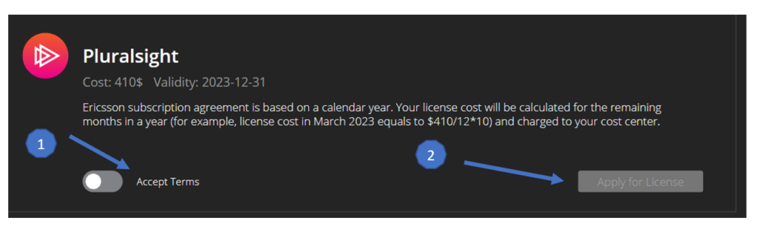
Thereafter, contact your manager to request expedited approval. The typical turnaround to receive your license is 48 hrs., but it may take up to two weeks.
If you log in every 75 days to the Pluralsight portal, your license will be re-validated until December 31st of the current year. Otherwise, it will be deactivated.

License Validation
Activate your license from the email you received. Ensure you use your Ericsson email address if prompted for it. Your license is tied to it. If successful, you will be logged in.
Ensure you are signed in the skills portal of Pluralsight every time you want to access a premium course, by following the below steps:

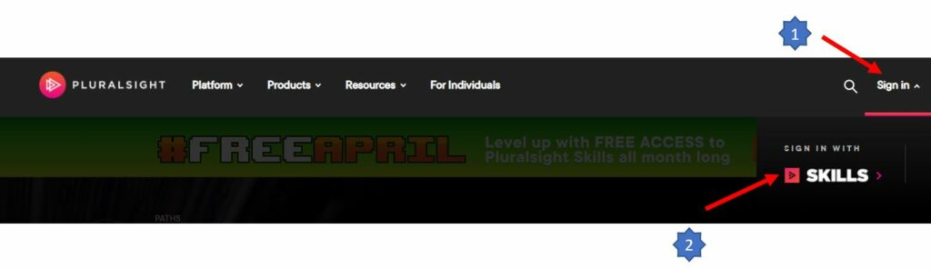
After login in, verify that you can access subscription only content, few examples are:
- https://app.pluralsight.com/paths/skills/analyzing-network-traffic-with-wireshark

Windows Platform Preparation
Estimated hours: 1.0

Third Party software installation
- If not already done, install VirtualBox. Any 7.x version should work just fine.
- https://www.virtualbox.org/
NOTE: Depending on the Ericsson platform you use, you may have to elevate the installation as “Administrator”.
- You will need a ssh client that supports proxy port forwarding. Few examples are SecureCRT, MobaXterm, or putty. Install and use which ever client you prefer. The lab instructions will provide screen captures for SecureCRT, putty and MobaXterm. If you chose a different client, refer to the official document for the client you chose to understand how to install it and create sessions with dynamic port forwarding.
- You will need a sftp client that supports proxy port forwarding like FileZilla or WinSCP. Install and use which ever client you prefer. Refer to official document for the client you chose to understand how to create sftp sessions reusing dynamic port forwarding.
- Optional but highly recommended applications:
  - Notepad++, VSCode

Disk space clean-up and availability
Perform a clean-up of your Windows platform to ensure you have at least 50 Gig of free storage space. Be mindful that your workshop is spread over several weeks, and you may have to do more disk space clean-up throughout the class if your other duties are also disk space heavy.
IMPORTANT: All the labs must be installed on your local drive in a directory that is NOT synchronized with OneDrive, not on external drives (like USB) nor any remote disks (like SharePoint). A potential solution would be to create a folder under C:/Users/[your_signum]/Unsync_Documents. Subsequently, download your OVA files and install your labs in that location.

Section A: Nocentino Lab Installation
Estimated hours: 2.0 hours (ensure you have secured the training time with your manager)

Download Nocentino lab OVA
The files are available at this location:
Your MS Team Channel: Files section:: FileBucket-1-2023
Download the Installation document and all the OVA for the Lab.

Install Nocentino lab OVA
Read the Installation document that you downloaded from the same folder in the earlier step and continue with the installation of your Nocentino lab
If successful, you should see the following Virtual Machines (VMs) in your VirtualBox environment:
FRR / Kube1 / Kube2 / Kube3 / Kube4
Power-up the FRR VM nodes, and log-in to it via the VirtualBox console and execute the command ‘ip a’. Get familiar with the 10.81.10.x ip address range used.
Proceed with the same for each of the other VMs, one at a time. The first boot is usually more CPU/disk intensive.

Test your SSH client sessions.
Log-in to each of the VMs via your ssh client and execute the command ‘df -h’ in each of them. Get familiar with the disk usage statistics.
NOTE: you must connect your FRR first. The Kube-1 to 4 sessions is reusing the tunnel created by the FRR.
RECOMMENDATION: When you create your ssh sessions, we highly recommend you use distinct colors for EACH VM. Preferably a color that you like for kube-1 and unusual colors less attractive for FRR and kube2-4. After your cluster is created, you will process 99% of your commands on kube-1 only. The colors are a visual safety protection.

Understand Lab Environment
FRR
- Your FRR is a jump box/router/DNS for your labs, it can be seen as a data center router, a demarcation between the external world and your lab. IMPORTANT You will not perform any commands on this jump box/router node. The color trick recommended in the earlier lesson should help you avoid mistakes.
Kube-1
- On the Pluralsight WBL, the instructor’s Control plane node is named c1-cp1. Your kube-1 will become your Control Plane node. Most of your Kubernetes commands will be done on this node. Your CP node is named my-ubuntu-1. You will need to adapt your commands to match this. It is done on purpose so that you get used to adaptation of commands in the real world. EVERY cloud infrastructure is different.
Kube-2 to Kube-4
- On the Pluralsight WBL, the instructor’s lab worker nodes are named c1-node1, c1-node2, c1-node3, etc. Your kube-2 to kube-4 will be used as worker nodes. As you probably guessed, yours will also have different names.
Adaptation skills
- Each of your VMs above will have a different name and a different IP address compared to the instructor on Pluralsight. It’s done on purpose to trigger your adaptation skills. No cloud or virtual infrastructure will have the same ip addresses and same hostnames. Consequently, this will expose you to this situation and you will have to adapt some of your commands. For example, if an ip address is needed for a specific command, you may then have to use your lab’s ip address range instead of the ip address range of the instructor’s lab in Pluralsight.

Personalize Lab Environment
This lesson will change the prompt of your lab to personalize it to you. Log in to your Kube-1 using the ssh session you created during your lab installation. Process the following script and answer the questions:
- wget -qO /tmp/prompt.sh https://raw.githubusercontent.com/martin-eric/cn-class/main/prompt_setup.sh && bash /tmp/prompt.sh && rm -rf /tmp/prompt.sh
Logout and log back into all your Kube-1 sessions. Notice your prompt should reflect your name and signum.

Send “Nocentino Lab Ready” Screenshot
Send an email to your facilitators with “Nocentino Lab Ready (your signum)” as title, and include a screen capture showing all 5 VMs are imported to your VirtualBox, Running, and connected via your ssh console. Below is an example of what it should look like using SecureCRT. If you are using putty or MobaXterm your screen shot will vary but should still show all the required information.
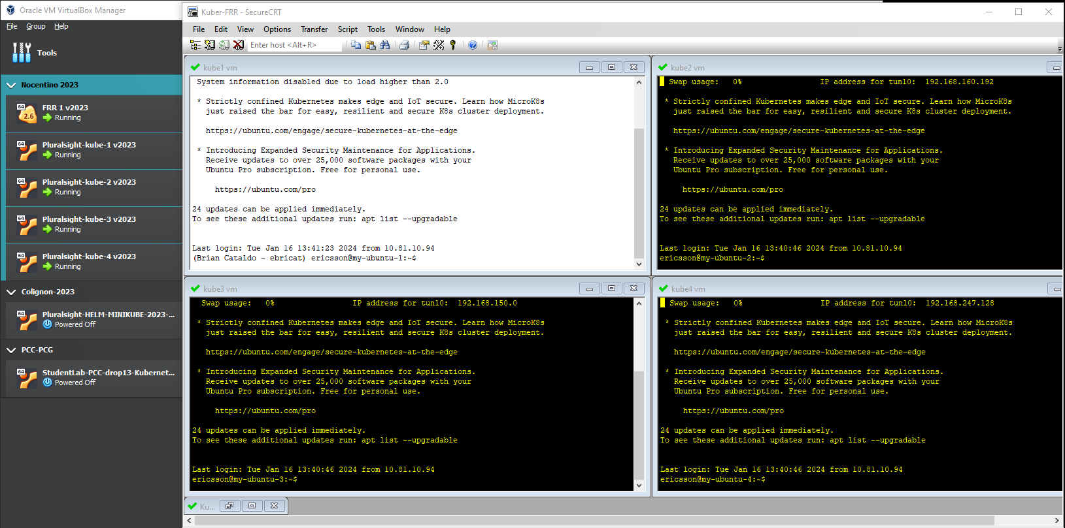

Understand the curriculum flow with Pluralsight
This playbook will give you the flow of the workshop. You will be guided to go watch videos and perform exercises that are on the Pluralsight modules. When you are done with a module, come back to this playbook to follow the next proper step.

Understand On-premises vs. Off-premises vs. Hyperscaler
This lab is composed of 4 Virtual machines using your windows platform resources. This configuration is considered on-premises “On-prem”. The instructor on Pluralsight will show you exercises on other environment (off-premises/Hyperscaler) like Google or Azure. Only proceed with the exercises that apply to the “on-prem” environment. However, understand the other environment exercises as they are great exercises that can be applied post workshop.

Section B: Kubernetes Installation and Configuration Fundamentals
Estimated hours: 3 hrs. Lecture + 3 hrs. exercises (ensure you have secured the training time with your manager)

Watch the video modules and download exercises
- Instructions
Every k8s section will be taught on Pluralsight, you will need to download the exercise files relevant for the module. The instructor will use them in his lab as he teaches you.
You will use the same exercises files and perform the commands on your own lab. You can cut ‘n paste his command directly in your own lab with minimal changes. (99% of the times they work as is). See below warnings.
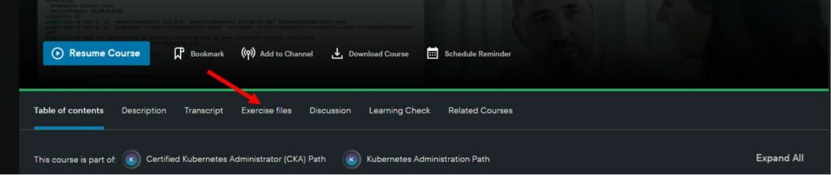
As you progress in the curriculum, the commands will become more complex.
*WARNING* Ask your instructor if there are known workarounds that need to be applied to this Section
*REMINDER* The instructor on Pluralsight will show you exercises on other environment (off-premises/Hyperscaler) like Google or Azure. Only proceed with the exercises that apply to the “on-prem” environment. However, understand the other environment exercises as they are great exercises that can be applied post workshop.
- Video and exercise files of the section:
  - https://app.pluralsight.com/library/courses/kubernetes-installation-configuration-fundamentals/table-of-contents

Section C: Manage the Kubernetes API Server and Pods
Estimated hours: 3 hrs. Lecture + 3 hrs. exercises (ensure you block training time on your calendar)

Watch the video modules and download exercises
- Instructions
  - Download the exercise files relevant for the module and continue with the videos.
- Video and exercise files of the section:
  - https://app.pluralsight.com/library/courses/managing-kubernetes-api-server-pods/table-of-contents
*WARNING* Ask your instructor if there are known workarounds that need to be applied to this Section
*REMINDER* The instructor on Pluralsight will show you exercises on other environments (off-premises/Hyperscaler) like Google or Azure. Only proceed with the exercises that apply to the “on-prem” environment. However, understand the other environment exercises as they are great exercises that can be applied post workshop.

Section D: Manage Kubernetes Controllers and Deployments
Estimated hours: 3 hrs. Lecture + 3 hrs. exercises (ensure you block training time on your calendar)

Watch the video modules and download exercises
- Instructions
  - Download the exercise files relevant for the module and continue with the videos.
- Video and exercise files of the section:
  - https://app.pluralsight.com/library/courses/managing-kubernetes-controllers-deployments/table-of-contents
*WARNING* Ask your instructor if there are known workarounds that need to be applied to this Section
*REMINDER* The instructor on Pluralsight will show you exercises on other environment (off-premises/Hyperscaler) like Google or Azure. Only proceed with the exercises that apply to the “on-prem” environment. However, understand the other environment exercises as they are great exercises that can be applied post workshop.

Section E: Manage Kubernetes Storage and Scheduling
Estimated hours: 3 hrs. Lecture + 3 hrs. exercises (ensure you block training time on your calendar)

Watch the video modules and download exercises
- Instructions
  - Download the exercise files relevant for the module and continue with the videos.
- Video and exercise files of the section:
  - https://app.pluralsight.com/library/courses/configuring-managing-kubernetes-storage-scheduling/table-of-contents

*WARNING* Ask your instructor if there are known workarounds that need to be applied to this Section
*NOTE* You can use any of kube-2 to kube-4 as your storage node. Only 1 is needed.
*WARNING* Ask your instructor if there are known workarounds that need to be applied to this Section
*REMINDER* The instructor on Pluralsight will show you exercises on other environment (off-premises/Hyperscaler) like Google or Azure. Only proceed with the exercises that apply to the “on-prem” environment. However, understand the other environment exercises as they are great exercises that can be applied post workshop.

Section F: Manage Kubernetes Networking, Services, and Ingress
Estimated hours: 3 hrs. Lecture + 3 hrs. exercises (ensure you are on-track)

Watch the video modules and download exercises
- Instructions
  - Download the exercise files relevant for the module and continue with the videos.
- Video and exercise files of the section:
  - https://app.pluralsight.com/library/courses/configuring-managing-kubernetes-networking-services-ingress/table-of-contents
*WARNING* Ask your instructor if there are known workarounds that need to be applied to this Section
*REMINDER* The instructor on Pluralsight will show you exercises on other environment (off-premises/Hyperscaler) like Google or Azure. Only proceed with the exercises that apply to the “on-prem” environment. However, understand the other environment exercises as they are great exercises that can be applied post workshop.

Wrap up of your Nocentino lab
Do not delete your Nocentino Lab from Virtualbox as you will need it for your group exercises and your final test.
Review your disk space situation on your Windows platform. *IMPORTANT*

Section G: HELM Lab Installation
Estimated hours: 1.0 hour (ensure you are on-track)

Download HELM lab OVA
The files are available at this location:
Your MS Team Channel : Files section :: FileBucket-2-2023
Download the Installation document and the OVA for the Lab.

Install HELM lab OVA
Read the Installation document that you downloaded from the same folder in the earlier step and continue with the installation of your HELM lab.
Review your disk space situation on your Windows platform before attempting to installation *IMPORTANT*
If successful, you should see the following Virtual Machines (VMs) in your VirtualBox environment:
Pluralsight-HELM-MINIKUBE
Power-up the FRR VM nodes first, and the new HELM VM via the VirtualBox console and execute the command ‘ip a’. Get familiar with the 10.81.10.x ip address range used. The first boot is usually more CPU/disk intensive.

Section G (cont.): Package Applications with Helm for Kubernetes
Estimated hours: Estimated hours: 3 hrs. Lecture + 5 hrs. exercises (ensure you stay on-track)

Watch the video modules and perform the exercises
- Instructions
  - As per your lab installation document, all the exercises are already included in the OVA image. Consequently, do not download them from Pluralsight.
  - Your instructor already installed and configured the binaries from lab 1 to lab 4 for time’s sake on your Minikube VM. Therefore, watch and understand what Phillip Collignon does in those lab1 to 4, but do not re-install them. Your first hands-on lab will be lab 5.
- Video and exercise files of the section:
  - https://app.pluralsight.com/library/courses/kubernetes-packaging-applications-helm/table-of-contents
- *WARNING* Ask your instructor if there are known workarounds that need to be applied to this Section

Section H: HELM continuation and wrap up
Estimated hours varies (ensure you stay on-track)

HELM Wrap up instructions
Finish all the earlier sections on Pluralsight.
Discuss with your instructor how the group exercises will be set up and the expectations.
Review your disk space situation. If you must, the HELM lab can be deleted in VirtualBox.
Remember to take out your personalized work if you wish prior to deletion. You can sftp your files using your port forwarding knowledge.
Keep your Nocentino lab in VirtualBox as you will need it for your group exercises and your final test.
Review your disk space situation on your Windows platform before attempting to installation *IMPORTANT*
Delete the HELM VM if you need free space.

Section I: Group Exercise #1
Estimated hours: 4.0 hours (ensure you stay on-track with your peers)

Lab preparation
Power up FRR + all 4 nodes in the Nocentino lab
Ensure you have no leftovers of resources from earlier exercises. A good hint would be to use ‘kubectl get all -A’. A clean environment should only show resources under the kube-system namespace.

Warm-up #1
- Workbook files of the section:
  - Your MS Team Channel: Files section: GE1 :: GE1-Warm-up

Group Exercises questions #1
- Workbook files of the section:
  - Your MS Team Channel: Files section: GE1 :: GE1-Exercises

Section J: Group Exercise #2
Estimated hours: 4.0 hours (ensure you stay on-track with your peers)

PCC Lab preparation
You will need to install a new lab. It will be a one node k8s lab, with images of an old Packet Core Controller (PCC).
Review your disk space situation on your Windows platform. You will need 50Gig free space to install it. Delete the HELM VM if you need free space.
The files are available at this location:
  - Your MS Team Channel: Files section: FileBucket-3-2023
Read the Installation document that you downloaded from the same folder in the earlier step and continue with the installation of your PCC lab.
If successful, you should see the following Virtual Machines (VMs) in your VirtualBox environment:
StudentLab-PCC-drop13-Kubernetes
Power-up the FRR VM nodes first, and the new PCC VM via the VirtualBox console and execute the command ‘Ip a’. Get familiar with the 10.81.10.x Ip address range used. The first boot is usually more CPU/disk intensive.

Warm-up #2
- Workbook files of the section:
  - Your MS Team Channel: Files section: GE2:: GE2-Warm-up

Group Exercises questions #2
- Workbook files of the section:
  - Your MS Team Channel: Files section: GE2: GE2-Exercises

Section K: Final assessment test
Estimated hours: 3.0 hours (are you ready 😊)

Lab preparation for Final test
Power up FRR + all 4 nodes in the Nocentino lab
Ensure you have no leftovers of resources from earlier exercises.

Final test
- Workbook files of the section:
  - TBD location

